Jacob C. Vaught EMCH 332 Assignment #9 Due 11-30-2022
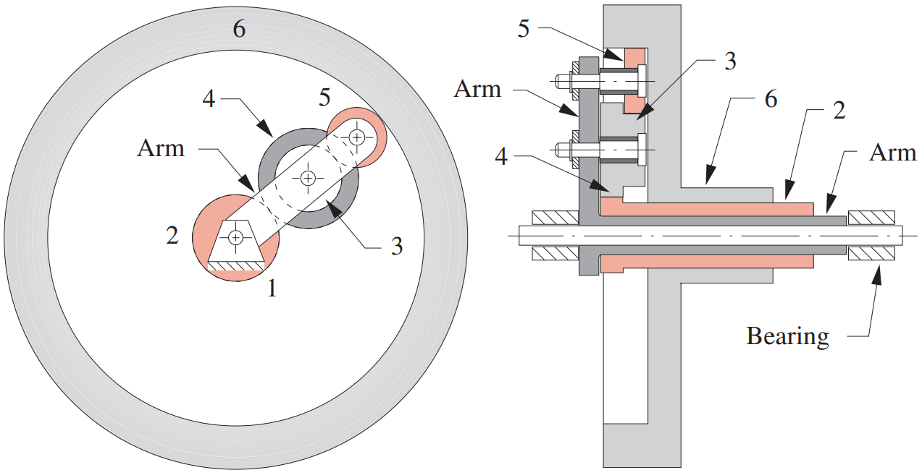
Provided Data:
$$\left\{\begin{matrix}N_{2}=30 & N_{3}=25 & N_{4}=45 & N_{5}=50 & N_{6}=200 & ω_{2}=50 & ω_{6}=0\end{matrix}\right\}$$
Data Requested:
$$\left\{\begin{matrix}ω_{ARM}=? & ω_{5}=? & ω_{34}=?\end{matrix}\right\}$$
Calculations:
$$\left\{\begin{matrix}ω_{2}N_{2}=-ω_{34}N_{4}+ω_{A}\left(N_{2}+N_{4}\right) \\ ω_{A}\left(N_{2}+N_{4}\right)+ω_{34}N_{3}=-ω_{5}N_{5}+ω_{A}\left(N_{2}+N_{4}+N_{3}+N_{5}\right) \\ ω_{A}\left(N_{2}+N_{3}+N_{4}+N_{5}\right)+ω_{5}N_{5}=ω_{6}N_{6}\end{matrix}\right\}$$
$$⇒\left\{\begin{matrix}1500=-45ω_{34}+75 \\ 75ω_{A}+25ω_{34}=-50ω_{5}+150ω_{A} \\ 150ω_{A}+50ω_{5}=0\end{matrix}\right\}=\left\{\begin{matrix}ω_{34}=-40.9 \\ ω_{ARM}=-4.545 \\ ω_{5}=13.6363\end{matrix}\right\}$$

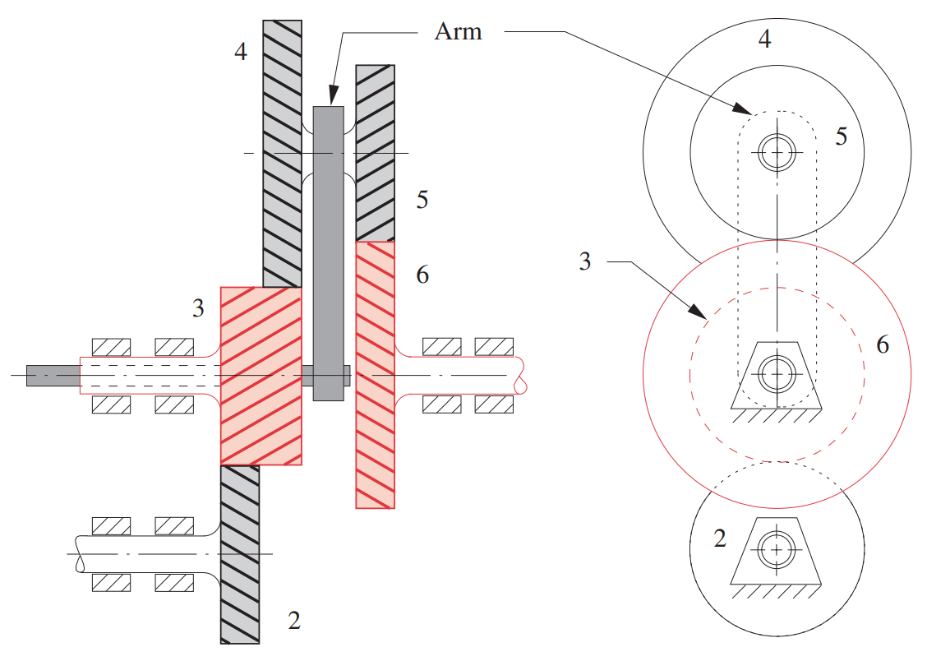
Provided Data:
$$\left\{\begin{matrix}N_{2}=40 & N_{3}=20 & N_{4}=45 & N_{5}=30 & N_{6}=35 & ω_{2}=50 & ω_{6}=0\end{matrix}\right\}$$
Data Requested:
$$\left\{\begin{matrix}ω_{ARM}=? & ω_{5}=? & ω_{45}=?\end{matrix}\right\}$$
Calculations:
$$\left\{ω_{3}\begin{aligned}ω_{2}N_{2}=-ω_{3}N_{3} \\ N_{3}=-ω_{45}N_{4}+ω_{A}\left(N_{6}+N_{5}\right) \\ N_{6}=-ω_{45}N_{5}+ω_{A}\left(N_{6}+N_{5}\right)\end{aligned}\right\}$$
$$⇒\left\{\begin{matrix}2000=-20ω_{3} \\ 20ω_{3}=-45ω_{45}+65ω_{A} \\ 0=65ω_{A}-30ω_{45}\end{matrix}\right\}=\left\{\begin{aligned}ω_{3}=-100 \\ ω_{45}=133.33 \\ ω_{ARM}=61.538\end{aligned}\right\}$$

